

First Semester PRACTICE Examination, 2010

Question/Answer Booklet

PHYSICS
Stage 3
Answers

Student Number: In figures

In words

Time allowed for this paper
Reading time before commencing work: Ten minutes
Working time for paper: Two hours and thirty minutes

Materials required/recommended for this paper

To be provided by the supervisor
This Question/Answer Booklet
Formulae and Constants Sheet

To be provided by the candidate
Standard items: pens, pencils, eraser, correction fluid, ruler, highlighters
Special items: non-programmable calculators satisfying the conditions set by the Curriculum Council for this course

Important note to candidates
No other items may be taken into the examination room. It is your responsibility to ensure that you do not have any unauthorised notes or other items of a non-personal nature in the examination room. If you have any unauthorised material with you, hand it to the supervisor before reading any further.
Structure of this paper

Section | Number of questions available | Number of questions to be answered | Suggested working time  (minutes) | Marks available | Percentage of exam
Section One:  Short response | 14 | 14 | 50 | 54 | 30
Section Two:  Problem-solving | 6 | 6 | 70 | 90 | 50
Section Three:  Comprehension | 2 | 2 | 30 | 36 | 20
 |  |  | (150) | (180) | 100

Instructions to candidates

1. The rules for the conduct of Western Australian external examinations are detailed in the Year 12 Information Handbook 2010. Sitting this examination implies that you agree to abide by these rules.

2. Write answers in this Question/Answer Booklet.

3. You must be careful to confine your responses to the specific questions asked and to follow any instructions that are specific to a particular question.

- Working or reasoning should be clearly shown when calculating or estimating answers.

5. Spare pages are included at the end of this booklet. They can be used for planning your responses and/or as additional space if required to continue an answer.
  - Planning: If you use the spare pages for planning, indicate this clearly at the top of the page.
  - Continuing an answer: If you need to use the space to continue an answer, indicate in the original answer space where the answer is continued, i.e. give the page number. Fill in the number of the question(s) that you are continuing to answer at the top of the page.

Section One: Short Response

This section has 14 questions. Answer all questions. Write your answers in the space provided. It is worth 54 marks or 30% of the total for the paper.

Suggested working time for this section is 50 minutes.
_______________________________________________________________________

Question 1 [3 marks]

A ball moves at a constant speed in a vertical circle when the string breaks at the position shown.

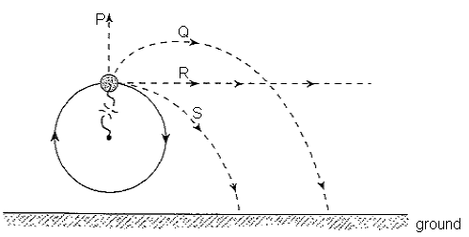

The ball will then move along which of the indicated paths?
S
Write the letter corresponding to your answer in the box on the right. (1)

Briefly explain the reason for your choice.

When the string breaks the ball will continue to move tangentially to the circular path i.e. along R. (1) However, the ball will be influenced by the downward force of gravity and will follow a curved (parabolic) path to the ground i.e. it will move along path S. (1)

Question 2 [4 marks]

Two vertical wires with tensions as indicated support a uniform 14.0 kg, 3.0 m long beam carrying an object of mass M as shown.

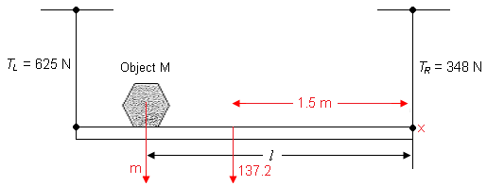

At what distance l from the right-hand wire is the object located?

Fup = Fdown  625 + 348 = 137.2 + m  ∴m = 835.8 N  (1) | Taking moments about x (1)  =  (1.5 x 137.2) + 835.8 l = 625 x 3 (1)  Solving l = 1.997 = 2.00 m (1)

Question 3 [3 marks]

Sound is travelling in the direction PQ in the diagram below. Which of the paths labelled
A, B, C or D best shows the path taken by the sound after it moves from layer 1 into layer 2? Give a brief reason to support your answer.

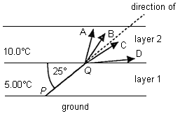
Answer = C (1)

Reason: velocity of sound wave will increase ⇒ wave will refract away from the normal. (1) Since the difference in temperature is small, the change in direction (deviation) will only be small. (1)

_______________________________________________________________________
Question 4 [5 marks]

A microphone connected to a computer is used to detect how the sound pressure varies with time when a loudspeaker emits a note of a single frequency. The appearance of the wave pattern is shown below.

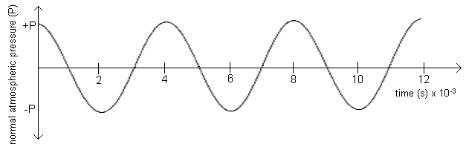

- What is the period and frequency of the wave?

Period T = 4 x 10⁻³ sec (1)

f = = = 250 Hz (1)

- Assuming the speed of sound in the room is 346 ms⁻¹, calculate the wavelength of the sound.

v = λf
∴ λ = = 1.38 m (1)

- If the air temperature increased during the experiment, what would happen to the value of the wavelength of the sound? Explain your answer.

Speed will increase but the frequency will remain unchanged (source of the wave is the same). (1) Therefore the wavelength ? must also increase. (1)

Question 5 [4 marks]

A projectile is launched from the ground with an initial velocity of 140 ms⁻¹ at an angle θ above the horizontal, as shown in the diagram below.

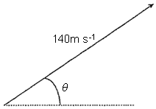

The time of flight of the projectile is measured as 18.7 seconds and its range as 1.98 km.

Show that the launch angle θ is approximately 41º.

R = ?H. t = (v cos ) t (1)

∴ t = i.e. 18.7 = i.e. 18.7 = (1)

∴ cos = = 0.7563 (1)

Solving = 40.9° i.e. approximately 41° (1)

Question 6 [3 marks]
Sam is an athlete preparing for the London Olympics. His specialty event is the hammer throw. He spins the 7.26 kg hammer in a horizontal circle of radius 1.60 m, rotating it once every 1.55 seconds.

Assume Sam’s arms make a straight line with the hammer handle. At this speed the hammer makes an angle of 20.4º to the horizontal.

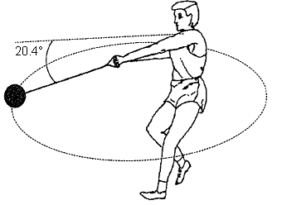

(a) What is the speed of the hammer as it moves in the circle?

v = = = 6.49 ms⁻¹ (1)

(b) Although Sam is swinging the hammer at a constant speed it is actually accelerating.
Why?

The direction of movement is continually changing as it moves in circular path ⇒ there is a change in velocity and hence an acceleration (1)

(c) Determine the magnitude of the centripetal force acting on the hammer as it moves in its circular path.

Fc = =

= 191 N towards centre of circle (1)

Question 7 [4 marks]

An air horn is a type of wind instrument and so it can be modelled by a pipe. The length of the horn used was 20 cm and the sound it produced had a frequency of 426 Hz.

Assume the speed of sound is 340 ms⁻¹.
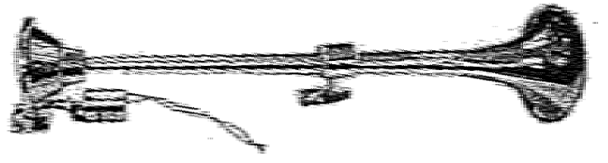

Show, by appropriate calculation, that this data indicates that a closed pipe, not an open pipe, models an air horn.

Wavelength of sound λ = = = 0.798 m (1)

If an open pipe l = = 0.40 m (1)

If a closed pipe l = = 0.20 m (1)

Since the known length is 20 cm (0.20 m) it follows that the air horn is a closed pipe (1)

Question 8 [3 marks]

A storage shelf has a strut at each end. What is the most important reason for this strut? Briefly explain the physical principle involved.

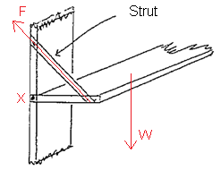
The strut is used to ensure that the shelf is in equilibrium i.e. it will not fall down. (1)

The load placed on the shelf and the weight of the shelf itself will create a clockwise torque about x. (1)

The strut will create an anti-clockwise torque about x which will ensure that the shelf will remain stable i.e. = (1)

Question 9 [4 marks]

Linda and Emma decide to investigate what happens when sound waves pass through a narrow opening. They set up a single loudspeaker behind a wall with a 0.30 m gap in it, as shown in the diagram below.

They then intend to measure the amplitude of sound with a microphone attached to a computer, as Emma walks along the line QR.

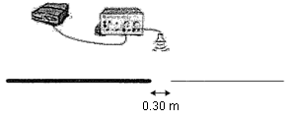

Q R

Linda thinks this a waste of time since the gap will just let through a “beam” of sound, with sharply defined limits, like the grey curve in the graph below. Emma, however, believes that this is not true, and they adjust the frequency output from the loudspeaker and make the measurement. The result is shown below as the dashed line in the graph.

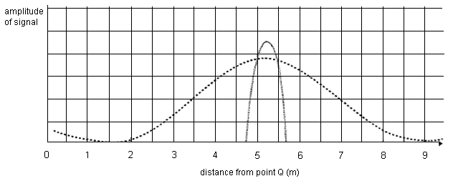
Why did the students obtain a result that was different to the one predicted by Linda?

The sound waves will diffract as they pass through the narrow gap. (1) As a result the waves will spread ‘sideways’ and sound energy will be detected well away from the opening (1)
Assume f = 1000 Hz ∴ λ = = 0.35 m
Since λ d, diffraction is likely to be significant

Question 10 [5 marks]

The International Space Station (ISS) is in orbit around the Earth at an altitude of 380 km.

(a) Use the data below to determine the orbital period of the ISS in minutes.

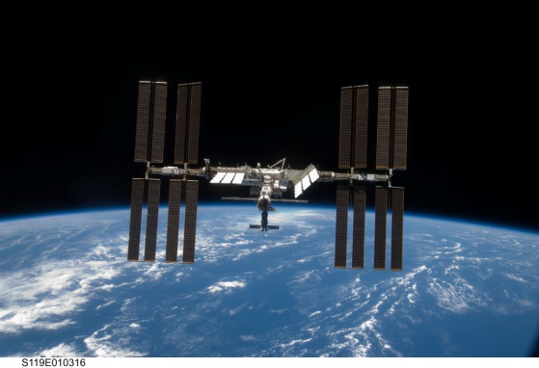

Orbital radius = 6.4 x 10⁶ + 380 x 10³
= 6.78 x 10⁶ m (1)
N² = = (1)

i.e. N² = 5.903 x 10⁷ so v = 7.68 x 10 ms⁻¹

since v = (1)

T = = = 5.548 x 10³ s

= 92.5 minutes (1)

- Which row of the table (A to E) best describes the acceleration and speed of the
ISS, and the net force acting on it while it orbits around the Earth?

 | Acceleration | Speed | Net force
A. | Zero | Constant | Zero  D (1)
B. | Zero | Constant | Finite
C. | Finite | Constant | Zero
D. | Finite | Constant | Finite
E. | Finite | Changing | Finite

Question 11 [4 marks]

Currently, the space probe Cassini, is between Jupiter and Saturn as shown in the diagram below.

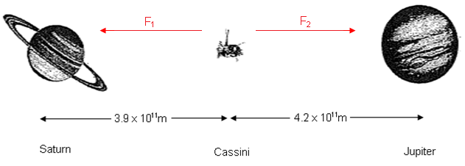

Calculate the total (net) gravitational force exerted on Cassini when it is 4.2 x 10¹¹ m from Jupiter and 3.9 x 10¹¹ m from Saturn.

Useful Data:

Mass of Cassini | Mass of Jupiter | Mass of Saturn
2.2 x 10³ kg | 1.9 x 10²⁷ kg | 5.7 x 10²⁶ kg

Force acting F₁ = = 
due to Saturn
= 5.499 x 10⁻⁴ N (1)

Force acting due F₂ = = 
to Jupiter
= 1.581 x 10⁻³ N (1)

∴ net force = F₂ – F₁ (1) = 1.03 x 10⁻³ N towards Jupiter (1)

Question 12 [4 marks]

Two identical loudspeakers are connected to a signal generator as shown below.

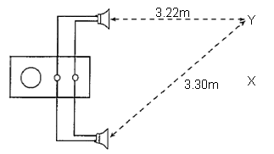

- Will a microphone placed at X detect a minimum or maximum intensity of sound? Explain.

Maximum intensity waves will arrive at X ‘in phase’ so constructive interference will occur (2)

- When the microphone is moved slowly in the direction XY, the first minimum of intensity is detected at Y. What is the wavelength of the sound emitted by the loudspeaker?

Path difference = 3.30 – 3.22
= 0.08 m (1)

For a minimum intensity destructive interference will occur
i.e. waves must arrive 180° out of phase
∴ PD = = 0.08
⇒ wavelength = 0.16 m (1)

Question 13 [4 marks]

Two satellites, S₁ and S₂, are in circular orbits around a planet. Satellite S₂ has twice the mass and twice the orbital radius of satellite S₁.

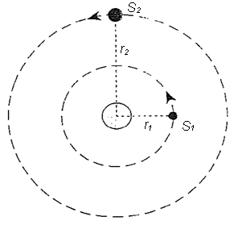

What is the ratio of the centripetal force acting on S₂ to that acting on S₁? [S₂:S₁]
Justify your answer with appropriate working.

The centripetal force acting on the satellite is provided by the gravitational force exerted by the earth.

F₁ = F₂ = (1)

= x 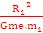 (2)

= 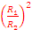 x

= x

=

i.e. F₂ = F₁ (1)

Question 14 [4 marks]

In your summer job with the Department of Road Transport your supervisor has told you that street signs should no longer be suspended as shown in Diagram A. In order to save money she would prefer a shorter, perfectly horizontal cable, as shown in Diagram B.

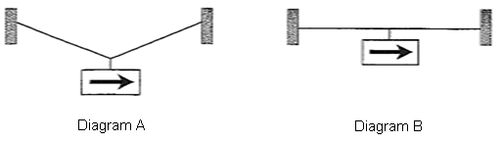
T
T
W
T
T
W

Using the principles of physics, discuss why the situation in Diagram B is totally impossible.

The weight force W acting on the sign acts vertically downwards. (1)

To remain in equilibrium, the net force = 0
i.e. F_{up} = F_{down} (1)

In diagram B the sideways tension forces T to have no vertical component.
i.e. there will be no vertically upwards force to cancel the downwards weight force W. (1)

∴ the arrangement shown in B is not possible. (1)

End of Section One

Section Two: Problem Solving 90 marks (50% of total)

This section has six (6) questions. You must answer all questions. Write your answers in the space provided.

Suggested working time for this section is 70 minutes.
_______________________________________________________________________

Question 15 (13 marks)

On 12 February 2001, a spacecraft named the NEAR Shoemaker landed on Eros, a peanut shaped asteroid (pictured below) between the orbits of Earth and Mars.

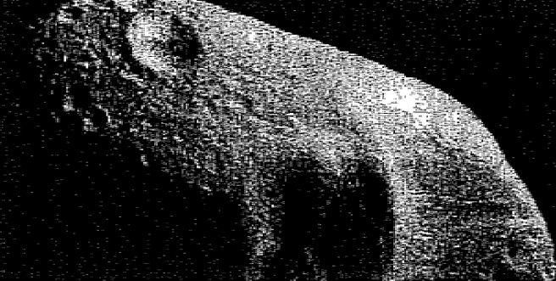

Before landing on Eros, the spacecraft orbited at a radius of 50 km from the centre of mass of Eros with an orbital period of 5.9 x 10⁴ seconds (about 16 hours).

- Use this information to find the mass of Eros.
[4 marks]
v = = = 5.325 ms⁻¹ (2)

v² = so m = = (1)

= 2.13 x 10¹⁶ hg (1)

- On the diagram below, draw one or more labelled arrows to show any force(s) acting on the spacecraft as it orbits Eros. You can ignore the effect of any other astronomical bodies.
[2 marks]
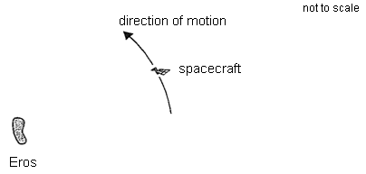(2)
F
- The 450 kg spacecraft had a weight of 2.5 N when it landed on the asteroid. What is the acceleration due to gravity on the surface of Eros?
[2 marks]
w = mg

g = = (1)

∴ g = 5.56 x 10⁻³ ms⁻² (1)

- Use your answer to (c) to estimate the diameter of Eros. For simplicity, you may assume Eros to have a spherical shape.
[5 marks]

g = (1)

R² = = = 2.555 x 10⁸

∴ R = 1.598 x 104 m (2)

So diameter = 2 x 1.598 x 10⁴ (1) = 3.20 x 10⁴ m
(i.e. 32km) (1)

Question 16 (15 marks)

A batsman hits a cricket ball (from ground level) at a speed of 30.0 ms⁻¹ and at an angle of 36.9º to the horizontal as shown below. Air resistance can be ignored.

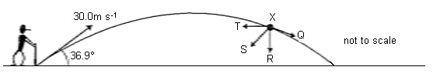

- What is the maximum height that the ball reaches?
[4 marks]
v_{H} = v cos = 30 x cos 36.9 = 23.99 ms⁻¹
v_{v} = v sin = 30 x sin 36.9 = 18.01 ms⁻¹ (1)
at highest point v_{v} = 0 (1)
i.e. v² = u² + 2as
0 = 18.01² – 19.6s
i.e. s = = 16.6 m (1)
i.e. maximum height = 16.6 m (1)

- The distance from the batsman to the boundary is 70 m. Does the batsman hit a “six”?
[To hit a “six” means that the ball must travel in the air beyond the boundary line]

[5 marks]
Time to reach max height
v = u + at Range
o = 18.01 – 9.8 t (2) R = v_{H}. t
∴ t = = 1.838 sec = 23.99 x 3.676
= 88.2 m (1)
i.e. total flight time
t = 2 x 1.838 ∴ The batsman will hit a six (1)
= 3.676 s (1)

- Which of the arrows (Q to T) in the diagram above best represents the resultant force on the ball at point X? Justify your answer.

[2 marks]
R (1) – the only force acting on the ball is the downward force of gravity (1)

An advertising sign is now placed near the boundary at a distance of 72 m from the batsman as shown in the diagram below.

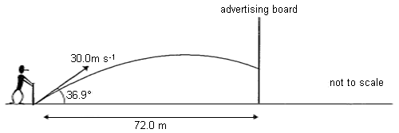

- Assuming the ball is hit in exactly the same way as in the previous question, at what height above the ground will the ball strike the advertising sign? You must show your working.
[4 marks]
Time to travel 72m
K = = 3.001 sec (1)
Vertical displacement at t = 3.001 sec
S = ut + ½at²
= (18.01 x 3.001) – 4.9 x 3.001²
= 9.92 m (2)
i.e. the ball hits the sign 9.92 m above ground (1)

Question 17 (15 marks)

A group of students were listening to the sounds from a cassette player and from a signal generator at the same time. The students noticed that sometimes there was a regular variation in the loudness of the sound. This phenomenon is known as “beats”. The diagram below shows the resultant wave form produced. The number of beats heard each second is always equal to the difference in the frequencies of the sounds involved.

Beat frequency = |f2 – f1| where f1 and f2 are the frequencies of the sounds involved.

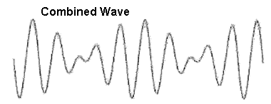

- Explain, using physical principles, how beats are produced.
[4 marks]
Loud sounds – constructive interference when waves are ‘in phase’. (2)

Softer sounds – destructive interference when waves are ‘out of phase’. (2)

- For one of the trials, when the signal generator produced a note of 425 Hz, a total of 60 beats were detected in 12 seconds. What are the possible frequencies of the note emitted from the cassette player?
[3 marks]
No. of beats/sec = = 5 Hz (1)

Since beat frequency = |f₁ – f₂|

f₁ (1) = 425 5 = 42- Hz or 430 Hz (1)

- When the signal generator frequency was increased the beat frequency was observed to decrease. What was the actual frequency emitted from the cassette player? Justify your answer.
[3 marks]
If the frequency of the generator is now increased above the original 425 Hz it will now be closer to the 430 Hz of the cassette player (1)
i.e. fewer beats will be heard (1)
∴ actual frequency = 430 Hz (1)

In another experiment, the students connected the signal generator to a loudspeaker which produces a sound of 2.0 kHz. The loudspeaker is placed a distance of 10.2 m from a wall.

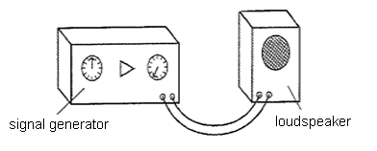

- How long does it take for the sound to return to the loudspeaker?
[2 marks]

v =

t = = = 2.948 x 10⁻² sec (1)

∴ total time = 2 x 2.948 x 10⁻²

= 5.90 x 10⁻² sec (1)

The loudspeaker is now placed in a tank of carbon dioxide gas. The frequency remains
at 2.0 kHz.

- What effect does this have on the wavelength of the sound? Explain your answer.
[3 marks]
[The speed of sound in carbon dioxide gas = 269 ms⁻¹]

Since λ = , decreasing the speed of sound (CO₂ v = 269, air 346) (2) means that the wavelength must also decrease (1)

Question 18 (17 marks)

The diagram shows a 0.15 kg toy plane suspended by a string. The toy plane is rotating with a constant speed in a horizontal circle. The string makes an angle 33º with the vertical.

(a) Draw and label, on the diagram below, the applied forces acting on the toy plane.

[2 marks]
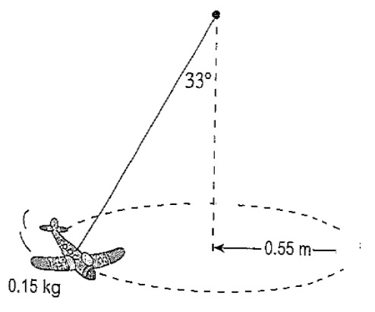
T (tension) (1)
W (weight) (1)

(b) Draw on the diagram below the resultant force acting on the toy plane.

[2 marks]
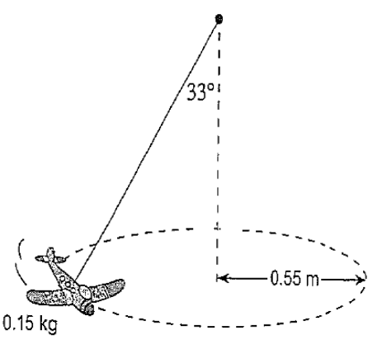
(1)
F
Resultant force
F (towards centre of circle)

(c) What is the tension in the string?

[3 marks]
F_{up} = F_{down} (1)

T cos 33 = w

T = = (1)

= 1.75 N (1)

(d) Calculate the magnitude of the centripetal force experienced by the toy plane.

[4 marks]
F_{C} = T sin (2)

= 1.75 sin 33
T

= 0.955 N (2)

Or use F_{C}² = W² + T² – 2WT cos 33
F_{C}
W
So F_{C} = 0.955 N

(e) Hence, determine the speed of the toy plane as it moves in the circular path.

[3 marks]
FC =

∴ v² (1) = = (1)

∴ velocity = 1.75 ms⁻¹ (1)

(f) Over time the speed of the toy plane would decrease. When this occurs, does the
angle between the string and the vertical increase or decrease? Justify your answer.

[3 marks]
If the speed of the plane decreases the centripetal force acting will also decrease. However, the weight of the plane w will remain constant. (1)

Original New (1)

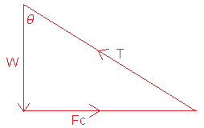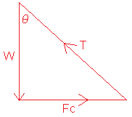

From the vector diagram, the angle is smaller when the speed is decreased. (1)

Question 19 (15 marks)

Wendy was investigating the speed of waves along stretched strings. She generated these waves by plucking a 0.760 m length of guitar string. She knew the speed (v) of the waves was given by the relationship

v =

where T is the tension in the string and μ is the mass per unit length of the string.

She plotted her results in the graph below.

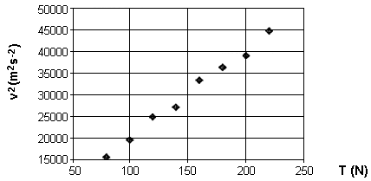

(a) Why did Wendy plot v² against T and not just v against T?
[2 marks]

A graph of v againt T will not produce a straight line as ‘v’ is not directly proportional to ‘T’. However, v² = so v² T (2)

(b) Verify that the units for μ are kgm⁻¹.
[2 marks]

v² = so = (1)
units = = kg m⁻¹ (1)

(c) Draw a line of best fit through the data points, and hence find the gradient of the line.
[4 marks]
Gradient = (2)

=

= 1.43 x 10² (2)

(d) Use your value of the gradient to determine the value of μ for the string.
[3 marks]
Since N² = (1)

Gradient =

∴ = = (1) = 7.00 x 10-3 kgm⁻¹ (1)

(e) When the guitar string is oscillating in its fundamental mode the wave pattern looks
something like this:

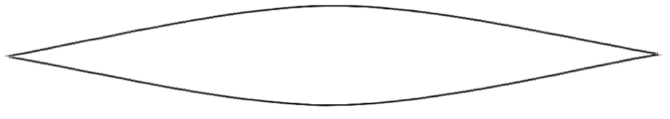

Sketch the wave pattern when the string is oscillating in its second and third harmonic forms.
[4 marks]

Second Harmonic  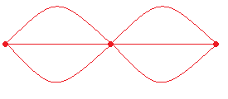  (2) | Third Harmonic  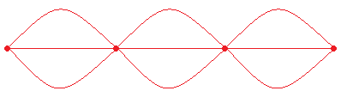  (2)

Question 20 (15 marks)

An 80 kg painter is using rigid plank supported by two trestles to paint the upper section of a wall, as shown in the diagram below.
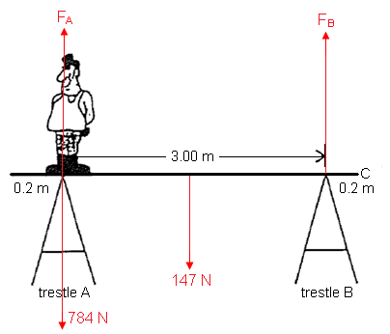
Assume the plank is rigid, uniform in composition and shape with a mass of 15.0 kg. The painter is standing directly above trestle A.

- Determine the magnitude of the upward force exerted by each trestle on the plank.

[5 marks]
Taking moments about A
= (1)
(147 x 1.5) = F_{B} x 3
F_{B} (1) = = 73.5 N upwards (1)
Since F_{up} = F_{down}
F_{A} + F_{B} = 784 + 147 (1)
∴ FA = 784 + 147 – 73.5 = 858 N upwards (1)

- Is it possible for the painter to stand at C and still have the system remain in equilibrium? Justify your answer with a simple calculation.
[4 marks]
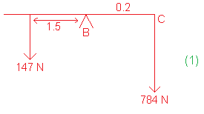
The ACW moment
= 147 x 1.5
= 221 Nm (1)
The CW moment
= 784 x 0.2
= 157 Nm (1)
Since the CW moment < AC moment the plank will NOT tip over
i.e. possible to stand at C (1)

- The painter walks along the plank from trestle A to trestle B.

Sketch a graph, plotting (on the vertical axis) the force trestle B exerts on the
plank against his displacement from A (on the horizontal axis) as the painter walks
along the plank from trestle A to trestle B.

Clearly mark the scales on each of the axes. Show any working here.
[6 marks]

Let the distance the man is from A be ‘d’.
Taking moments about A
=
(147 X 1.5) + 784. D = F_{B} x 3
i.e. F_{B} = 73.5 + 261.3 d (3)

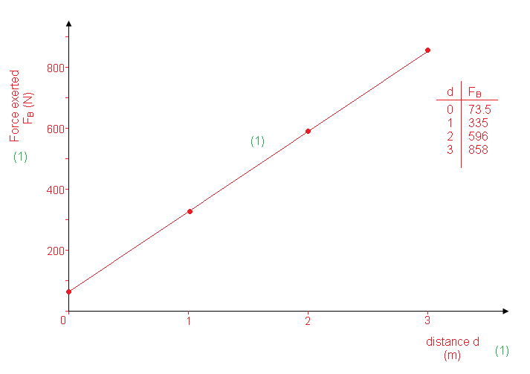

End of Section Two

Section Three: Comprehension (36 marks or 20% of total)

This section contains two (2) questions. You must answer both questions. Write your answers in the space provided.

Suggested working time for this section is 30 minutes.
_______________________________________________________________________

Question 21 (20 marks) ESTIMATION of GRAVITATIONAL ACCELERATION

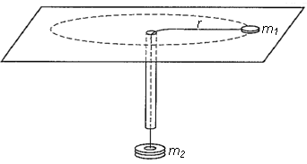

An experiment is performed using the apparatus above. A small disk of mass m₁ on a frictionless table is attached to one end of a string. The string passes through a hole in the table and an attached narrow, vertical plastic tube. An object of mass m₂ is hung at the other end of the string.

A student holding the tube makes the disk rotate in a circle of constant radius r, while another student measures the period P.

The relationship between these variables is given below:

P² = 4π² m₁ r (where g = acceleration due to gravity)
g m₂

The procedure is repeated, and the period P is determined for four different values of m₂, where m₁ = 0.012 kg and r = 0.80 m.

Three trials were performed for each value of m₂ used.

The data obtained is tabulated below.

Trial 1 Trial 2 Trial 3 Average
mass m₂ (kg) | Period P (s) | Period P (s) | Period P (s) | Period P (s)
0.020 | 1.40 | 1.38 | 1.42
0.040 | 1.05 | 1.06 | 1.04
0.060 | 0.79 | 0.80 | 0.79
0.080 | 0.73 | 0.75 | 0.75

- Which two important variables were controlled in this investigation?
[2 marks]

1st variable | Radius of circular path (1)
2nd variable | Mass of the object moving in circle (1)

- Is it appropriate to include the values of the period P from all three trials when finding the average period P? Explain your answer.
[2 marks]

Yes (1) – the data obtained for the 3 trials for each mass M2 are very consistent with each other (1)

- Determine the average period P. Write the values in the last column of the data table.
(2)
[2 marks]

- To obtain a straight line graph it is necessary to plot P² against 1/m₂.

Complete the following table.

m₂  (kg) | 1/m₂  (kg⁻¹) | Average period  P (s) | P² (s²)
0.020 | 50 | 1.40 | 1.96
0.040 | 25 | 1.05 | 1.10
0.060 | 17 | 0.79 | 0.62
0.080 | 13 | 0.74 | 0.55
(1) (1) (1)

[3 marks]

- Plot a graph to show P² versus 1/m₂. Use the graph paper provided.
[4 marks]
(4)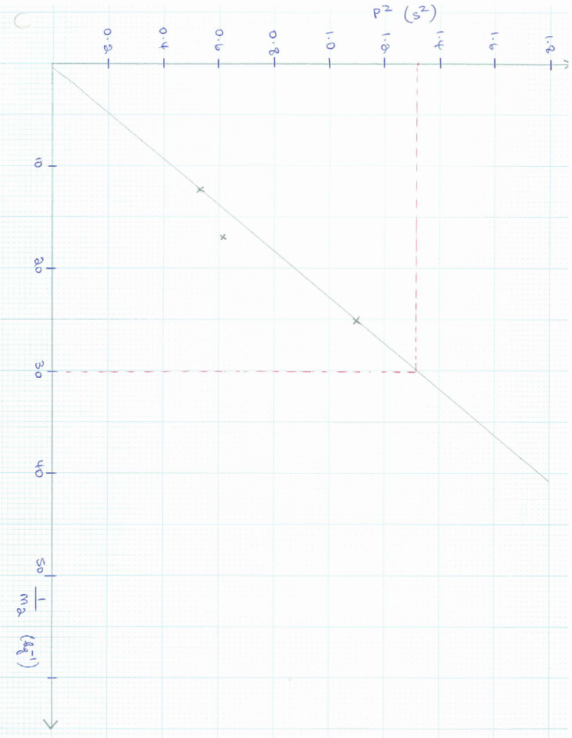
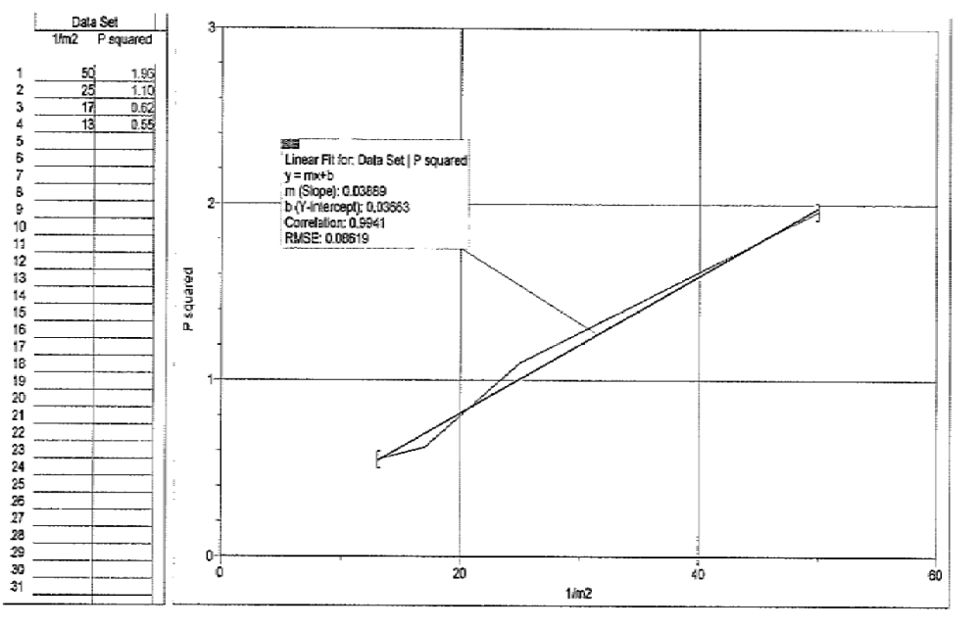

- Determine the gradient of the straight line obtained.
[3 marks]
Gradient = (1)

=

= 0.044 (1) kgs² (1)

- Use the gradient to calculate an experimental value of “g’.
[3 marks]
Since p² = 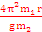

Gradient = 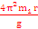 (1)

i.e. g = (1) = 8.62 ms⁻² (1)

(h) Comment on the accuracy of the value obtained for “g”.
[1 mark]
Value is close to 9.80 ms⁻² but not very accurate (1)

Question 22 THE DOPPLER EFFECT

In the normal discussion of pitch and frequency, both the source of the sound and the listener are assumed to be stationary. Here the pitch of the sound heard is characteristic of the source of the sound. If the source vibrates at 1000 vibrations per second then the listener hears a 1000 Hz tone. When there is relative motion between the source of the sound and the listener the pitch of the sound (as heard) is not the same as that when both the listener and source are stationary.

(Paragraph 1)

As an example, when a fire engine with its siren on is approaching you at high speed the pitch of the siren sounds much higher to you than when the fire engine is moving away from you. This apparent change in pitch is called the DOPPLER EFFECT after the person who first explained it. (Paragraph 2)

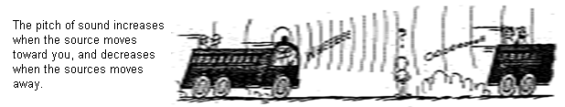

Of course, the frequency of the sound emitted remains unchanged, as does the velocity of the sound in the air. So why does the frequency appear to change?

Consider a source of sound vibrating at a frequency of "f" that is moving to the right at a speed v_{S}. The widening circles represent the successive compressions of the sound wave leaving the source. The motion of the source causes the sound waves to be crowded together in front of the source and to be spread further apart behind the source. The effect of this is to reduce the wavelength of the waves in front of the source and to increase the wavelength of the waves behind the source.
(Paragraph 3)
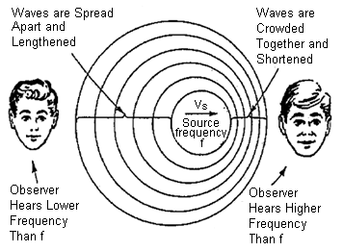

Since all of the waves travel at the same speed, an observer standing in front of the source will receive more than "f" waves each second while an observer behind the moving source will receive less than “f” waves per second. This change in observed frequency is called the Doppler Shift.

(Paragraph 4)

There is a mathematical relationship that allows us to determine the frequency heard in the case of a Doppler Shift.

observed frequency = f_{o} speed of sound = v

actual frequency of the source = f_{s} speed of the source = v_{s}

This relationship has a slightly different form, depending on whether the source of the sound is moving towards or away from a stationary observer.

Source moving towards the observer | Source moving away from the observer
f_{o} = f_{s} v/[v - v_{s}] ) | f_{o} = f_{s} (v/[v + v_{s}] )
(Paragraph 5)

The Doppler Effect is observed with all types of waves. Police radar guns use the shift in the frequency of microwaves to determine the speed of a moving car. Astronomers use the shift in the frequency of the light emitted by distant stars to determine information about the motion of those stars.
(Paragraph 6)

- What is the significance of the term “relative motion” as used in paragraph 1?
[2 marks]
It means that either the source of the sound or the observer must be moving while the other remains stationary i.e. one must be in motion. (2)

- When a source of sound moves towards you, would you expect to measure an
increase or decrease in the wave speed? Explain.
[3 marks]
Neither (1) – the speed of sound in a given medium will remain constant (2)

- The passage describes in detail what happens when a moving source of sound approaches a stationary observer. What is likely to be heard if the source remains stationary and the observer moves rapidly toward the source?
[3 marks]
The observer will now be moving relative to the source of the sound (1) – by moving rapidly towards the source the observer will detect an increase in the pitch of the sound (2)

- A sound of frequency 200 Hz is emitted by the horn of a car moving at 100 kmh⁻¹. Assuming the speed of sound is 340 ms⁻¹:

- What is the frequency of the sound heard by a person who is inside the car?
[1 mark]
200 Hz (1)

- What is the frequency of the sound heard by a stationary observer when the car is approaching her?
[3 marks]
v_{s} = = 27.8 ms⁻¹ (1)

f_{o} = f_{o} v/(v – vs)

= (1)

= 218 Hz (1)

- The passage mentions that the Doppler Effect can also occur with light waves. When this happens there is a change in the frequency of the light. As a result an observer will detect a corresponding change in the colour of the light.

With an appropriate calculation, confirm that the flashing blue light of a police car doesn’t appear to change as the police car approaches you at high speed.

Useful information:

Speed of light = 3.0 x 10⁸ ms⁻¹

Frequency of blue light = 7 x 10¹⁴ Hz (approximately)

You may need to ESTIMATE values for other quantities.
[4 marks]

Assume the police car is moving at 120km h⁻¹.

∴ v_{s} = = 33.3 ms⁻¹ (1)

f_{o} =

= 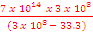 (2)

= 7 x 10¹⁴ Hz

i.e. the frequency is unchanged ⇒ colour will not change (1)

End of Section Three

There are no further questions in this examination

